Feta and Spinach Sandwich

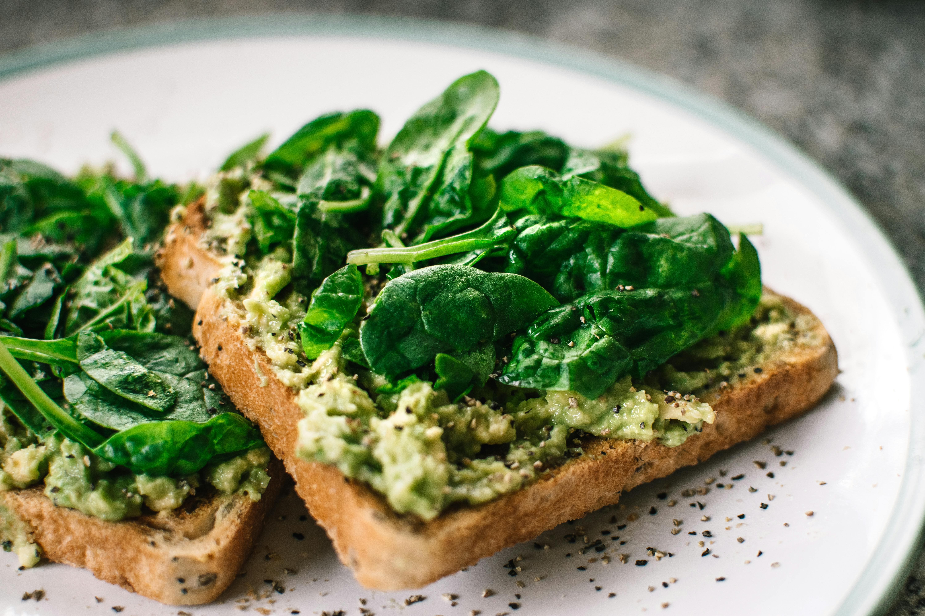

Ingredients
- Frozen spinach:
I use frozen spinach because I have it my refrigerator all the time. Using frozen spinach saves you time and this sandwich is ready in no time. Just grab it, leave it out and then saute it slightly in the pan to get rid of any water.
- Extra virgin olive oil:
By using extra virgin olive oil, you are not loading your sandwich with saturated fat but with heart healthy fat that also packs in antioxidants and flavor.
- Feta:
Authentic feta is made mainly with sheep’s milk and that will make a difference in the flavor. The tanginess pairs perfectly with the earthy spinach and the crunchy bread.
- Whole grain bread:
I have found a hearty whole grain bread from a local baker that only contains flour, yeast, and salt. Stay away from breads that are overly processed with too many additives. They will not grill well (and they aren’t that great for you either). And ignore the front of the pack “promises”. Just look at the ingredients.

Directions

- Start by carefully slicing the feta in very thin slices. Feta can crumble easily, but if you use a thin and sharp knife, you will be fine.

- Saute the defrosted spinach in 1 tsp oil. Add a pinch of salt, freshly ground pepper, and the dill.

- Brush the bread with olive oil, making sure the whole surface is covered.

- Place the bread in a pan over medium heat. Add a few slices of the cheese, then spread the spinach and then finish by layering the rest of the cheese. Cover with the second slice of bread. ** You can cut the slices in half.

- Grill for about 3 to 4 minutes until bread has browned, flip to the other side and grill for a few more minutes until cheese is soft and somewhat melted. Feta does not lose it shape that much when heated, but you will notice it, once you take a bite.

